HOME ASSIGNMENT - SQL JOINS AND HAVING

- From table planning_zone_nationalities, select 5 planning zones with the highest share of immigrants in the total population.
SELECT
planning_zone_name,population_total,
immigration_background_yes,
ROUND(immigration_background_yes/ population_total,2) AS immigrant_share
FROM `census-2022-470714.census_2022_berlin.planning_zone_nationalities` as N
Join`census-2022-470714.census_2022_berlin.planning_zone_mapping` AS M
ON N.planning_zone_id = M.planning_zone_id
ORDER BY immigrant_share DESC
LIMIT 5;

- Which planning zones have more than 15000 inhabitants, but less than 5000 inhabitants with immigrant background?
SELECT
planning_zone_name ,
population_total,
immigration_background_yes
FROM `census-2022-470714.census_2022_berlin.planning_zone_mapping` AS M
JOIN `census-2022-470714.census_2022_berlin.planning_zone_nationalities` AS N
ON M.planning_zone_id = N.planning_zone_id
where population_total >15000
AND immigration_background_yes <5000
LIMIT 5;

- Which district has the most immigrants, and which has the highest immigrants share in total population? Is it the same district?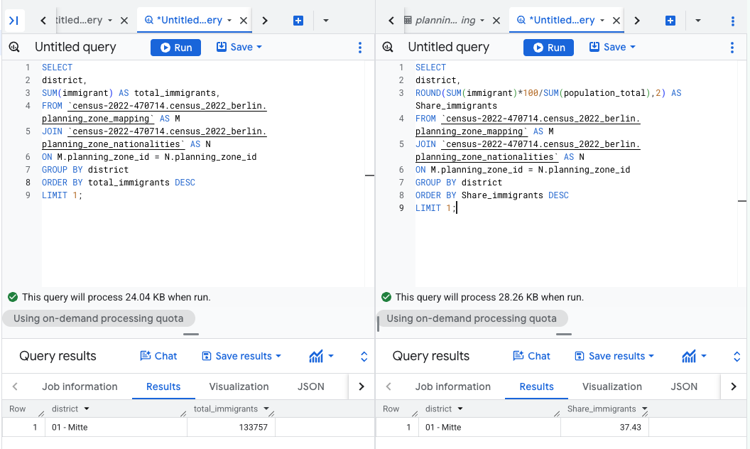

- Which planning zone has the most single parent households? What is the share of single parents in the overall population in that planning zone?
Tip: to calculate the share of single parents in the overall population, you need the numbers of single parents (which is equal to single parent households, as one such household by definition has one parent) and total population. No grouping needed as we are staying on planning zone level.

SELECT
N.population_total,
H.household_type_single_parents,
M.planning_zone_name,
ROUND (H.household_type_single_parents*100/N.population_total,2)
AS Single_parent_share
FROM `census-2022-470714.census_2022_berlin.planning_zone_households` AS H
Join `census-2022-470714.census_2022_berlin.planning_zone_nationalities` AS N
ON H.planning_zone_id = N.planning_zone_id
JOIN `census-2022-470714.census_2022_berlin.planning_zone_mapping` AS M
ON H.planning_zone_id = M.planning_zone_id
ORDER BY Single_parent_share DESC
LIMIT 15;

- Calculate the same metric (share of single parents in the overall population) per district (Now you need to GROUP BY).
SELECT
M.district,

SUM(H.household_type_single_parents) AS Total_single_parents,
SUM(N.population_total) AS Total_Population,
Round(SUM(H.household_type_single_parents)*100/SUM(N.population_total),2) AS Share_Single_Parent

FROM `census-2022-470714.census_2022_berlin.planning_zone_mapping` AS M
JOIN `census-2022-470714.census_2022_berlin.planning_zone_households` AS H
ON M.planning_zone_id = H.planning_zone_id
JOIN `census-2022-470714.census_2022_berlin.planning_zone_nationalities` AS N
ON M.planning_zone_id = N.planning_zone_id

GROUP BY M.district
ORDER BY Share_Single_Parent DESC;

- Write a query that returns district names with the average number of apartments per planning zone, but only those with this average above 4000.

SELECT
M.district,
ROUND(avg(apartments_total),0) AS Avg_apartments

FROM `census-2022-470714.census_2022_berlin.planning_zone_apartments` AS A
JOIN `census-2022-470714.census_2022_berlin.planning_zone_mapping` AS M
ON A.planning_zone_id = M.planning_zone_id

GROUP BY M.district
HAVING AVG(apartments_total) >4000
ORDER BY Avg_apartments DESC;
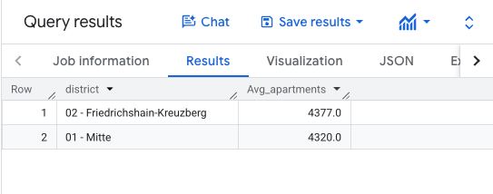

- Are there any quarters in Berlin, where less than 50% of apartments are rented? Use HAVING to show those quarters.

- *Are there any quarters in Berlin, where there are more rented apartments than households with children?
Tip: you can start by reusing the query from the previous task. There are two columns in the households table with the number of households with children.

